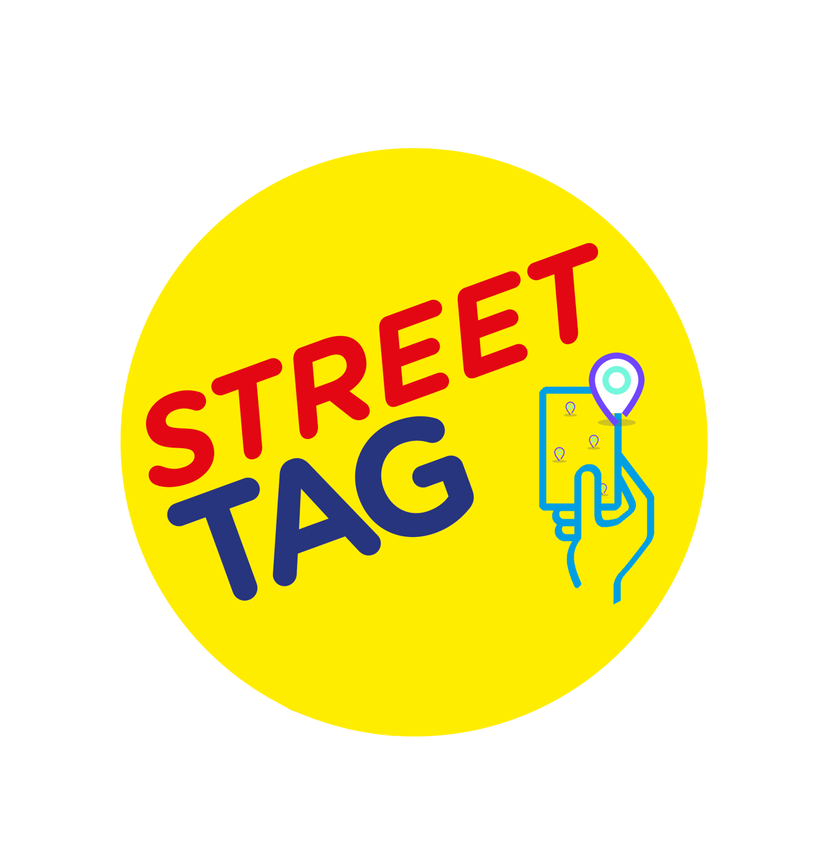
INTRODUCTION:
Street Tag is a free child and family-friendly mobile application that uses virtual tags to incentivize communities and families to become more physically active and boost mental health.
On the Street Tag app, you collect points assigned to virtual tags all-around your community including green spaces, once you are within a 40-meter radius of any virtual tag, your app will automatically collect the points, steps can also be synced and converted into Street Tag points. These points are on your school’s leaderboard in real-time, with prizes to be won at the end of each season.
It's lightning-fast and easy to create new tags on your preferred walking, running, or cycling route on Street Tag. Anyone can create virtual tags around them using the app.
Use the Street Tag 'Power Hour' to commit to an hour of exercise at least 15 mins in advance and have all your tag points collected during that hour tripled and maintain a daily streak of physical activity for even more bonuses.
Start using Street Tag to explore and boost your daily physical activity and mental health. Collect virtual tags, sync your steps, try different experiences in the virtual playground and WIN PRIZES.
Join the school team today!!
Cumbria Schools Leaderboard
We are delighted to announce that Church Walk will be participating in the Street Tag Cumbria Schools Leaderboard program.
With Street Tag, participants record the distance they walk, run, or cycle by collecting virtual tags with their smartphones at various locations, watching their total distance accumulate to climb up the Schools leaderboard; steps are converted into points by syncing their steps into the Street Tag app. This is designed to encourage families to walk and cycle to school, to be physically active, to connect with green spaces, and is an opportunity to rediscover their local area as well as earn rewards for their school.
The reward scheme for the top 3 schools( 1 Small Primary, 1 Large Primary, 1 Secondary ) in each season is £50 from each School game area (6) + Special school.
https://streettag.co.uk/faq
If you ever face any issues with the app, don't hesitate to contact us by raising a support ticket through the app settings, through our website at www.streettag.co.uk, or email us at support@streettag.co.uk or through our social media channels.
We wish you a Happy Tagging playful experience with lots of prizes to be earned.
Steps to join your School Team
- Install the app from Play Store/ App Store, open it and click on Sign up.
- Enter the valid details to Sign up - full name, username, email Id, and password, then click continue.
- Select the School Leaderboard from the leaderboard options and click continue.
- Select the Schools leaderboard (Borough/ District / SGO area) from the given list, then pick your schoolteam from the list and click continue.
- Enter your preferred gender, and you can fill in the other optional details if you want. Then click on SignUp.
- Verify with your Email/ Phone number.
- After the verification step, please answer the questionnaire.
- Congratulations! Your account is ready for use.
Tips for Parents/Guardians to add a child as a player in their team.
  - Create an Email ID for your child.
  - A parent can add a max of 2 children as players C1 and C2.
  - Click on the 'add a child' icon in the settings of the app.
  - Fill in all the details to add a player.
  - Go to the app Settings > click Profile.
  - Select your C1 and C2 option and click add to complete activation.
  - Once a child is added as a player. You will see the C1/ C2 option appear on the main map home screen.
  - While tagging with your children, please click/tap on C1/C2 to collect a tag for them.
Steps to create the tags if there aren’t any tags.
  - Please stand at the location where you want to create new tags.
  - From the app’s map home screen, click on the ‘create tags’ button at the top of the screen.
  - Click the “I’m awesome, give me tags” button.
  - The app will create new tags for you if there aren’t enough existing tags around.
Features of the App
Menu (top left)
- Leaderboard: The leaderboard displays your rank, School team name, and the number of pointsyour school has.
- Message Board: This is your message board where you can view regular updates from Street Tag HQ and important announcements or opportunities. You will receive a notification when a new message has been shared, and we recommend you check this board regularly.
- Dashboard: You can see your team’s scores and individual players’ scores. Miles/distancecovered.
- Tags can be seen on the main screen map. The tags are yellow. Once they are scanned they turnred. A tag cannot be re-scanned within an hour. 5. Tags with Star are more than 50 points value.
- A set of 18 tags will earn a bonus of 200 points.
- Playground: All the app features are listed on it.
Power Hour is a flexible hour during the day for you to collect TRIPLE POINTS by walking, cycling, and running to collect virtual tags.
When you tag during your power hour, you earn triple points per each virtual tag that you successfully collect. You can pick your ‘Power Hour' of choice timeslot at least 15 minutes in advance. You can select up to 7 days of Power Hour slots in advance. When your Power Hour starts, there will be a countdown for that hour and all the 'tags' (not steps) that you collect during that hour will be triple points, except for Saturdays between 9:15 AM and 11 AM Power Hour will not be available for selection.
You do not have to exercise for the whole hour, you can exercise for the whole hour or you can do as much as you wish to do. The standard points assigned to each tag will remain outside of your selected power hour.
Steps collected from indoor and outdoor activities can be converted into Street Tag points through the app with Fitbit, Apple Watch, Garmin, inbuilt pedometer, or by uploading screenshots of your steps.

